+---------------------------------------+

| TimeZoneData |

+---------------------------------------+

| private timeZoneMap: Map<String, String>

+---------------------------------------+

| public TimeZoneData() |

| public getTimeZoneName(String): String |

+---------------------------------------+

+---------------------------------------+

| MainApp |

+---------------------------------------+

| private currentTimeZone: String |

| private localTimeMillis: long |

| private selectedLocation: String |

+---------------------------------------+

| public getCurrentTimeZone(): String |

| public getLocalTimeMillis(): long |

| public getSelectedLocation(): String |

| public main(String[]): void |

+---------------------------------------+

+---------------------------------------+

| TimeZoneConverter |

+---------------------------------------+

| public convertTime(MainApp): String |

+---------------------------------------+

+---------------------------------------+

| MainAppGUI |

+---------------------------------------+

| private currentTimeZoneInput: TextField |

| private localTimeMillisInput: TextField |

| private selectedLocationInput: TextField |

| private outputTextArea: TextArea |

+---------------------------------------+

| public start(Stage): void |

| private handleConvertButton(): void |

| private handleClearButton(): void |

| private isValidTimeZone(String): boolean |

| private parseLocalTimeMillis(): long |

| private showError(String): void |

|  |
| --- |
|  |

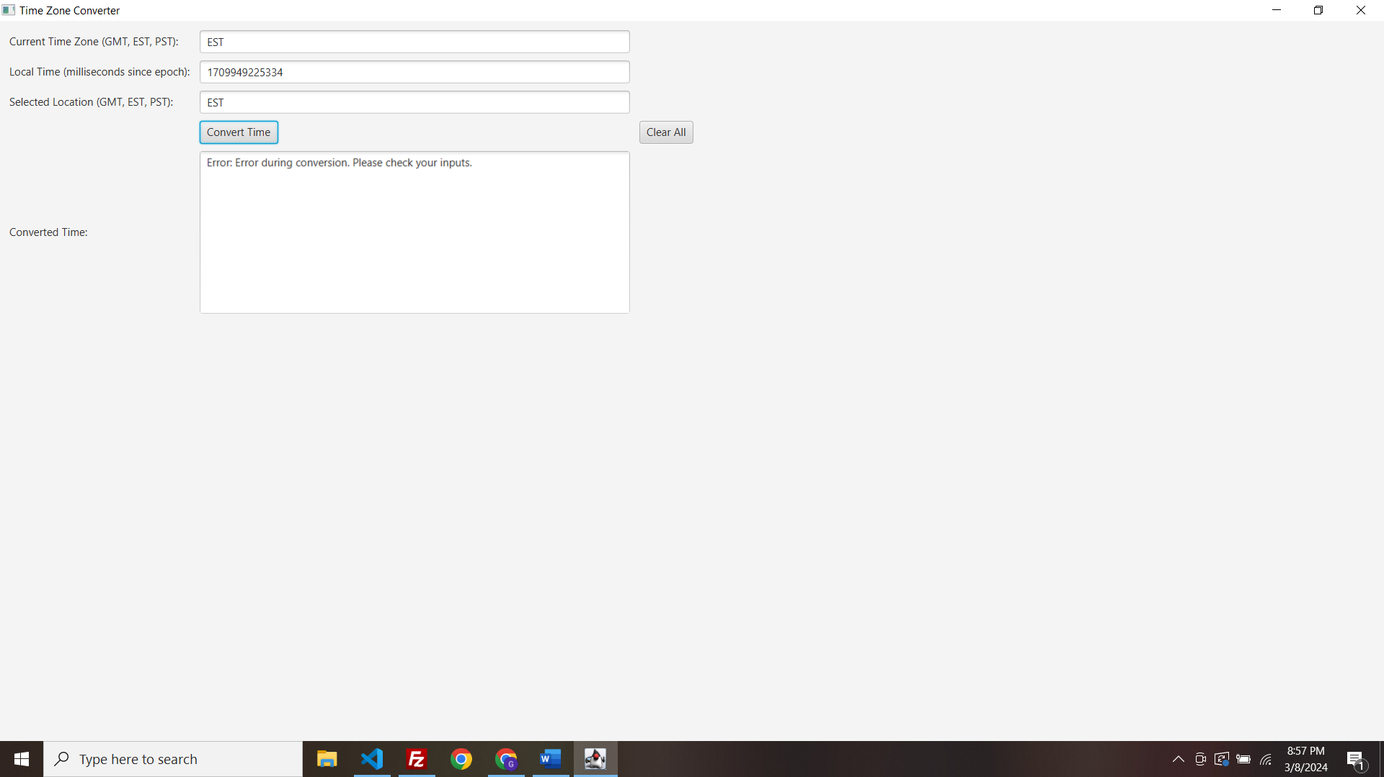

The code works fine when I run it from MainApp

